**CHOPIN 2nd INTERNATIONAL PIANO COMPETITION FOR CHILDREN AND YOUNG PIANISTS**

**May 05th – 09th, 2025 Istanbul, Turkey**

**CHOPIN 2.ULUSLARARASI PİYANO YARIŞMASI ÇOCUKLAR VE GENÇ PİYANİSTLER İÇİN**

**Mayıs 05 - 09, 2025 İstanbul, Türkiye**

# RULES I.

1. **The CHOPIN 2nd International Piano Competition for Children and Young Pianists will be organized online on May 05th - 09th, 2025 by Chopin International Academy of TOVAK Foundation in cooperation with the Maltepe University Conservatory, which are located in Istanbul, in Turkey.**

(The Chopin İnternational Academy of TOVAK Foundation is the Member of the International Federation of Chopin Societies since June 2016).

1. **The Competition will be in two age categories:**
   1. **Age category: up to 13 years old (including those aged 13 years old in 2025)**
   2. **Age category: from 14 up to 20 years old (including those aged 20 years old in 2025)**

Program for the I. and II. Age categories:

1. **J. S. Bach - one piano music composition (chosen by the Participant)**
2. **A music piece of the composer belonging to the country of the Participant.**
3. **F. Chopin- one piano music composition (chosen by the Participant)\***

*Participants of the II. age category can play one movement of the ;

F.Chopin-Piano Concerto in F Minor Op.21 or

F.Chopin-Piano Concerto in E Minor Op.11

Duration: I. Age category: max. 20 min.

II. Age category: max.25 min.

1. **The Competition Committee will decide who will qualify for the Com- petition.**
2. **Jury members, whose pupils participate in the Competition will not be able to vote for them.**
3. **All pupils can participate in the Competition.**

(This includes part – time or full – time students in the Conservatory, as well as the individuals taken private music lessons).

# II.

1. **Applications for the Competition should be sent by email in Turkish or English language to the address:**

[**irena.ulku@chopintovak.org**](mailto:irena.ulku@chopintovak.org) **using the Chopin International Academy of TOVAK Foundation Application Form (in Turkish or in English languages) and including the following points:**

 **Passport or ID copy**  **A current photo**

 **Vertical**

 **In high resolution (min.1920x1080, 300 dpi.)**  **Desirable formats: Pdf. Tiff., Pdf., Png.**

 **Confirmation proof of the Fee payment**

 **The e-mail attachment must contain the competitor's first and last name.**

1. **Applications on forms other than the official application form will not be accepted.**
2. **Applications should be filled out using printed text.**
3. **Incomplete or unsigned applications will not be accepted.**
4. **Applicants will receive an e-mail confirmation of submitted applications sent by e-mail within 5 days.**
5. **The Applications' deadline is April 30th, 2025.**
6. **Sent documents will not be returned.**
7. **Application Fee: 100 EURO (should be sent to the Bank account of the Competition Organizer).**

**Bank accounts details with the BIC/SWIFT code of the bank for Application Fee in**

**EUR currency:**

**AçıkChopin Uluslararası Piyano Yarışması Ücreti**

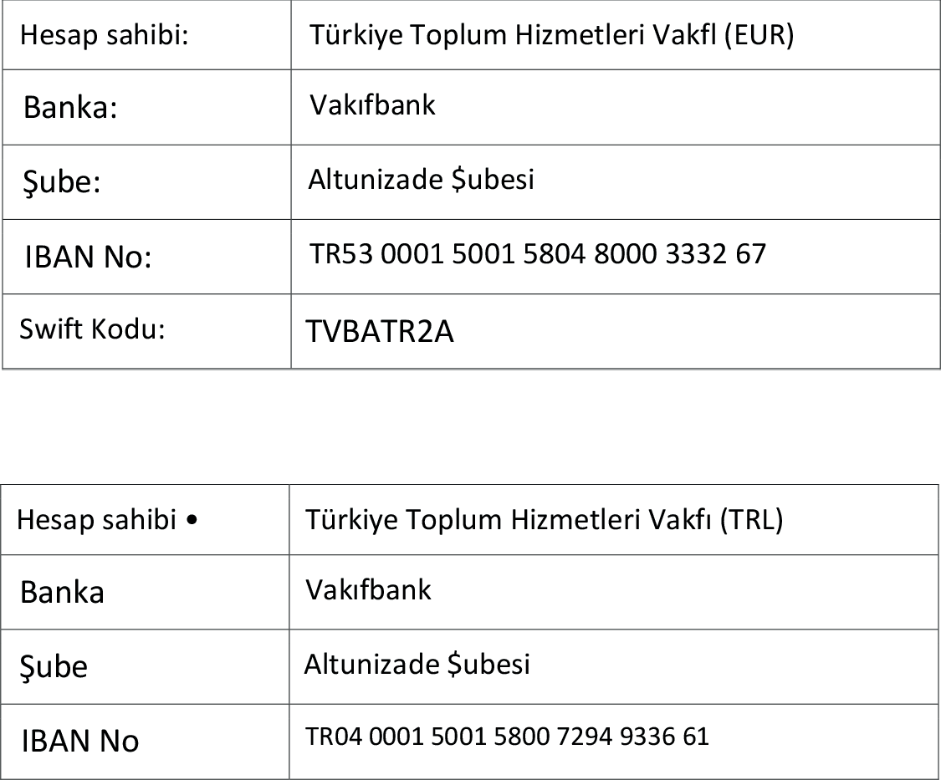

**Account holder:**

**Bank:**

**Branch:**

**IBAN No:**

**Swift Code:**

**The Bank account to which TRL equivalent of the Application Fee will be deposited by Turkish citizens:**

**Account holder: Bank:**

**Branch:**

**IBAN No:**

**Explanation: Chopin International Piano Competition Fee, April 24 – 30, 2025.**

1. **Bank charges are covered by the Applicant.**
2. **Application fees must be deposited by April 25th, 2025.**
3. **After the examination of the written Applications by the Competition Board, the candidates will be notified of their approvals for the Competition.**
4. **The decisions of the Committee are final and cannot be appealed.**
5. **Obligatory Competition Repertoire should include the following: Name and surname of the composer, name of the composition, opus number. In the selected compositions of F. Chopin, please write the Edition of it.**
6. **At the beginning of the video recording, the Participant should introduce himself/herself, to say the names of the compositions, which he/she will play, should tell the title:**

CHOPIN INTERNATIONAL PIANO COMPETITION FOR

CHILDREN AND YOUNG PIANISTS and should put this video recording to his/her own YouTube channel and send the video links to the addresses: [irena.ulku@chopintovak.org](mailto:irena.ulku@chopintovak.org) and to [denizbicak@maltepe.edu.tr](mailto:denizbicak@maltepe.edu.tr)

This recording should have to be delivered by 23:59 on April 30, 2025.

1. **The Participant should adjust the camera position so, that the Participant can be recognized and his hands and his/her silhouette are clearly visible.**
2. **The video to be uploaded by the Participant must be understandable in terms of sound and image.**
3. **If the performance time exceeds 20 minutes in the I.st Age Category and 25 minutes in the II. nd Age category, the Jury will not consider the performance of the Participant.**
4. **All compositions should be performed by heart.**
5. **While preparing the Competition Program, all the editions of pieces can be used.**
6. **In case of the compositions of Fryderyk Chopin, it is suggested to use The Chopin National Edition edited by Prof. Jan Ekier.**

Various concert opportunities will be offered to the Participants who will be awarded in the Competition.

1. **The value of the awards and additional awards will be announced to the Audience later.**
2. **The award ceremony and the concerts of the winning participants will be held in Istanbul on May 15-16, 2025.**
3. **Accommodation and flight tickets of the participants from outside Istanbul will be provided by the organization.**
4. **All participants will receive Certificates of Participation in the Chopin 2nd**

International Piano Competition for Children and Young Pianists in Istanbul, Turkey, May 05th – 09th, 2025.

1. **The Jury may choose the best competitor to receive the Grand Prix Award.**

The Jury members were selected in cooperation with the Chopin International Academy of TOVAK Foundation in Istanbul, Turkey and with the Co-Organizer: Maltepe University Conservatory, Istanbul in Turkey.

The International Jury:

Dr Irena Maria Ülkü - PL/TR Chairman

Prof. Andreas Weber - AT

Prof. Dr. Dilek Yonat Batıbay - TR

Prof. Gökhan Aybulus - TR

Prof. Joanna Maria Lawrynowicz- Just- PL

Prof. Karol Radziwonwwicz - PL

1. **The Jury will judge based on the submitted video recordings sent by Participants.**
2. **The Jury will follow the rules set given by the Organizer.**
3. **The results of the Competition will be announced on May 09th, 2025.**
4. **The decision of the Jury is final and cannot be changed.**
5. **The list of awarded competitors will be published in alphabetical order after the end of each Age category's selection.**

# V.

1. **The Organizer reserves the right to use the Participant's image, sound and audio, radio and television recordings taken during the Competition, and the images taken at the place chosen by the Organizer without paying any additional fees to the Competitor.**
2. **Participant, by accepting to participate in the Competition, will be obligated to have agreed to all Competition regulations without the possibility to cancel them.**
3. **The Organizer has the right to make decisions, which are indisputable and unalterable.**
4. **All additional information is provided by the following:**

**CHOPIN International Academy of TOVAK Foundation in Turkey Dr Irena Maria Ülkü, Director of the Competition, Artistic Director**

**Competition e-mail address:**

[**irena.ulku@chopintovak.org**](mailto:irena.ulku@chopintovak.org)

Tel.: +90 (0 538) 885 18 35 (info. ENG)

Maltepe University, Conservatory in Istanbul

Prof. Dr. Çiğdem İyicil, the Chairman of the Competition Organization

Committee

E-mail address: [cigdemiyicil@maltepe.edu.tr](mailto:cigdemiyicil@maltepe.edu.tr) Tel.: +90 (0 542) 272 15 98 (info. TR)