
ElectrIcal-ElectronIcs EngIneerIng Department

GRADUATION PROJECT TITLE

Student name, ID

Student name 2, ID 2

Project Advisor
Asst./Assoc. Prof. Dr. ……..

Month, Year
Maltepe/İstanbul

PROJECT DESCRIPTION
<This section provides a thorough and detailed description of the design project, as well as the motivation for the work and possible utilization schemes for the intended outcome in practice. The steps that are considered to be taken throughout the design and implementation of the project need to be clearly presented in this section. Visual elements such as schematic depictions, illustrations, block diagrams and photographs of the intended design steps and those of similar or related previous designs should be utilized in order to provide the reader with a better understanding of the overall project. These should be first mentioned in the text and then appear later in the report, as shown in Figure 1.1.
At this point, it is important to emphasize that your design experience should be based on the knowledge and skills acquired in earlier course work and incorporating appropriate engineering standards and multiple realistic constraints.>
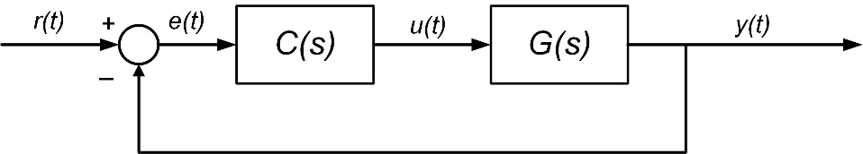
Figure 1.1 Block diagram of a unit feedback control system

<Note that, in your project proposal you should clearly define the objectives of the project, giving detailed information wherever possible. This proposal is your declaration to yourself (or your group) as well as your advisor on what the intended outcome is for the EE486 Graduation Project II you will undertake in the next term. The information and details provided here will be to your benefit as you progress your project.
Find the appropriate use of tables according to Maltepe University Electrical – Electronics Engineering program in Table 1.1.>

Table 1.1 Table example
Column Header 1 | Column Header 2
Column 1 | Column 2

REFERENCES
< If no sources are used in your project proposal, this section may be omitted.>
When a reference, such as a book [1-2], handbook [3], report [4], journal [5], or conference paper [6], or any other document is cited in the text, it should be properly listed in the References section. Use the IEEE Citation Reference format.>

[1] | J. K. Author, “Title of chapter in the book,” in Title of His Published Book, xth ed. City of Publisher, Country if not USA: Abbrev. of Publisher, year, ch. x, sec. x, pp. xx–xx.
[2] | B. Klaus and P. Horn, Robot Vision. Cambridge, MA: MIT Press, 1986.
[3] | Motorola Semiconductor Data Manual, Motorola Semiconductor Products Inc., Phoenix, AZ, 1989.
[4] | J. H. Davis and J. R. Cogdell, “Calibration program for the 16-foot antenna,” Elect. Eng. Res. Lab., Univ. Texas, Austin, Tech. Memo. NGL-006-69-3, Nov. 15, 1987.
[5] | R. E. Kalman, “New results in linear filtering and prediction theory,” J. Basic Eng., ser. D, vol. 83, pp. 95-108, Mar. 1961.
[6] | C. Berrou, A. Glavieux, and P. Thitimajshima, “Near Shannon limit error-correcting coding and decoding: Turbo-codes. 1,” in Proc. Int. Conf. Commun., Geneva, Switzerland, May 1993, pp. 1064–1070.

APPENDICES
<Supporting data that is not included in the main body may be provided in appendices. This data can be commercial catalogues or data sheets of components used, data sets, algorithms, computer programs and so on. For every new type of data provided there should be a new Appendix section. These sections are titled with a letter such as Appendix A, Appendix B. >

